First name LAST NAME∗

TITLE (original)

Title translated

Abstract: [200 words] Xxxxxxx xxxxxxxx xxxxxxx xxxxxxxxx xxxxxxxxxxxxxxxxxxxxxxxxx xxxxxxxxx xxxxxxxxxxxxxxx xxxxxxxxxxxxxxxx xxxxxxxxxxx xxxxxxxxxx xxxxxxxxxxxxxxxxxxxxxx xxxxxxxxxxxxxxxxxxxxx xxxxxxxxxxxxx xxxxxxxxxxxxx xxxxxx xxxxxxxxxxxx xxxxxxxxxxxxxxx xxxxxxxxxx xxxxxxxxxxxxxxxxx xxxxxxxxxxxx xxxxxxxxxxxxxxxxxx xxxxxxxxxxxxxxx xxxxxxxxxxxxxx xxxxxxxxxxxxxxxxxx xxxxxxxxx xxxxxxxxxxxxx xxxxxxxx xxxxxxxxxxxx xxxxxxxxxxx xxxxxxxxxx xxxxxxxxxx xxxxxxxxxxxxx xxxxxxxxx xxxxxxxxxxxxxxxxxxx xxxxxxxxxxxxxxx.

Keywords: [5 words] xxxxx xxxxxxxxxxx xxxxxxx xxxxxxxxxx xxxx.

* * *

Text text text text text text text. Text. text text text text text text text text text text text text text text text text text text text text text text text text text text text text text text text text text text text text text text text text text text text text text text text text text text text text text text text text text text text text text text text text text text text text text text text text text text text text text text text text text text text text text text text text text text text text text text text text text text text text text text. Text text text text text text text text text text text text text text text text text text text text text text text text text text text text text text text text text text text text text text text text text text text text text text text text text text text text text text text text text text text text text text text text text text text text text text text text text text text text text text text text text text text text text text text text text text text text text text text text text text text text text text texttext text text text text text text text text text text text text text text text text text text text text text text text text text text text text text text text text text text text text text text text text text text text text text text text text text text text text text text text text text text text text text text text text text text text text text text text text text text text text text text text text text text text text text text text text text text text text text text text text text text text text text.
Text text text text text text text text text text text text text text text text text text text text text text text text text text text text text text text text text text text text text text text text text text text text text text text text text text text text text text text text text text text text text text text text text text text text text text text text text text text text text text text text text text text text text text text text text text text text text text text text text text text text text text text.

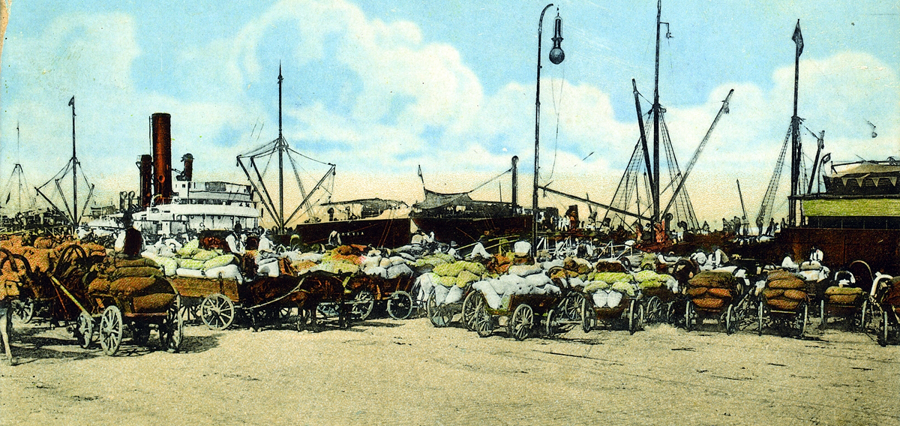
Fig. 1 – The port of Brăila in full activity - in the middle of the 19th century
Source: Valeriu Avramescu Collection 1983: 204.

Table 1
Wheat Exports from the Danubian Ports (1837-1852)
Quantities (in quintals) and Values (in sterling pounds)
Port | Galaţi |  |  | Brăila
Year | Quantity (quintals) | Average price (shillings) | Total value  (£) | Quantity (quintals) | Average price (shillings) | Total value  (£)
1837 | 12,494.83 | 8 | 73,785 | 9,626.02 | 7 | 53,054
1838 | 21,821.25 | 8 | 137,450 | 7,813.90 | 8 | 46,143
1839 | 19,098.89 | 12 | 180,454 | 18,185.20 | - | -
1840 | 29,283.49 | 13 | 299,738 | 16,840.46 | 12 | 159,115
1841 | 12,809.17 | 12 | 121,026 | 10,756.38 | 11 | 93,161
1842 | 19,644.63 | 11 | 162,409 | 20,336.30 | 10 | 160,121
1843 | 13,670.14 | 9 | 91,489 | 40,939.45 | 9 | 257,874
1844 | 21,150.92 | 8 | 133,228 | 44,183.81 | 9 | 295,705
1845 | 22,865.11 | 12 | 216,038 | 39,999.22 | 12 | 362,181
1846 | 14,085.20 | 13 | 149,718 | 41,597.72 | 15 | 425,784
1847 | 22,970.28 | 16 | 289,376 | 49,636.17 | 17 | 586,227
1848 | 14,428.50 | 11 | 124,966 | 20,255.40 | 10 | 159,484
1849 | 23,343.29 | 12 | 199,867 | 14,903.63 | 10 | 117,346
1850 | 17,863.62 | 12 | 161,750 | 35,979.49 | 10 | 269,126
1851 | 17,078.98 | 11 | 141,198 | 35,956.12 | 9 | 254,795
1852 | 23,820.58 | 11 | 206,311 | 43,637.18 | 10 | 343,584
Source: Ardeleanu 2014: 265
(dates recalculated by ____ from imperial quarters in quintals).

Source: Axenciuc 2000: 141-143.

REFERENCES

Buşe, Constantin, Comerţul exterior prin Galaţi sub regim de port–franc (1837–1883), Romanian Academy Publishing House, Bucharest, 1976
***“Commerce of the Danube” in Hunt’s Merchants’ Magazine and Commercial Review, New York, 3/XXVII, 1852, pp. 12-14
Enache, George, ”The Lower Danube and the Rio de la Plata Region in the Modern Age: Contrasted Perspectives on their Economic and Political Evolution” in Transylvanian Review, Vol. XXII, Supplement No. 2, 2013: Economic and Social Evolutions at the Crossroads of the World-System. Eastern and Central Europe from the Early Modern Age to the Twentieth Century, edited by Iosif Marin Balog, Rudolf Gräf, Cristian Luca, pp. 122-135
Herlihy, Patricia Ann McGahey, Russian Grain and Mediterranean Markets, 1774–1861 [PhD Dissertation], University of Pennsylvania, 1978
Lefebvre, Thibault, Etudes diplomatiques et économiques sur la Valachie, Paris, 1858
Mocanu, Emil Octavian, Portul Brăila de la regimul de porto franco la primul război mondial (1836-1914), Istros Publishing House, Brăila, 2012
The National Archives of the United Kingdom, P.R.O. F.O., Turkey, dos. 78/696 [TNA, FO].
Zeletin, Ştefan, Burghezia română. Originea şi rolul ei istoric, Bucharest, 1925

 Ph.D. Candidate, xxxx University, country; e-mail. Acknowledgements: This work was supported by the project ................................................................. Submitted: 12 September 2016 Revised version submitted: 13 October 2016 Accepted: 12 November 2016
Constantin Buşe, Comerţul exterior prin Galaţi sub regim de port–franc (1837–1883), Romanian Academy Publishing House, Bucharest, 1976, pp. 203-204.
George Enach, “The Lower Danube and the Rio de la Plata Region in the Modern Age: Contrasted Perspectives on their Economic and Political Evolution” in Transylvanian Review, Vol. XXII, Supplement No 2, 2013, pp. 124-127.
Constantin Buşe, op. cit., pp. 78-102.

